Chapter 4, Solution 61.

To find R_{Th}, consider the circuit in Fig. (a).

Let R = 2||18 = 1.8 ohms, R_{Th} = 2R||R = (2/3)R = 1.2 ohms.

To get V_{Th}, we apply mesh analysis to the circuit in Fig. (d).
6 Ω
(a)
2 Ω
b
a
6 Ω
6 Ω
2 Ω
2 Ω

(b)
2 Ω
b
a
2 Ω
2 Ω
18 Ω
18 Ω
18 Ω
R_{Th}
(c)
1.8 Ω
b
a
1.8 Ω
1.8 Ω

12V

+
−
−
+

V_{Th}
12V
6 Ω
(d)
2 Ω
b
a
6 Ω
6 Ω
2 Ω
i₁
i₂
i₃
2 Ω
12V

+
−
+

-12 – 12 + 14i₁ – 6i₂ – 6i₃ = 0, and 7 i₁ – 3 i₂ – 3i₃ = 12 (1)

12 + 12 + 14 i₂ – 6 i₁ – 6 i₃ = 0, and -3 i₁ + 7 i₂ – 3 i₃ = -12 (2)

14 i₃ – 6 i₁ – 6 i₂ = 0, and -3 i₁ – 3 i₂ + 7 i₃ = 0 (3)

This leads to the following matrix form for (1), (2) and (3),

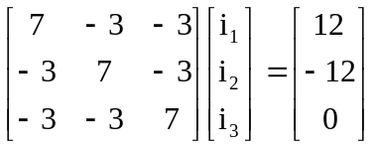

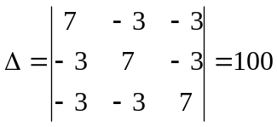, 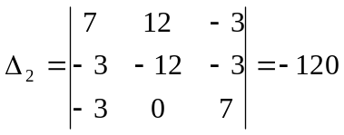

i₂ = Δ/Δ₂ = -120/100 = -1.2 A

V_{Th} = 12 + 2i₂ = 9.6 V, and I_{N} = V_{Th}/R_{Th} = 8 A

